**Analysing the style**

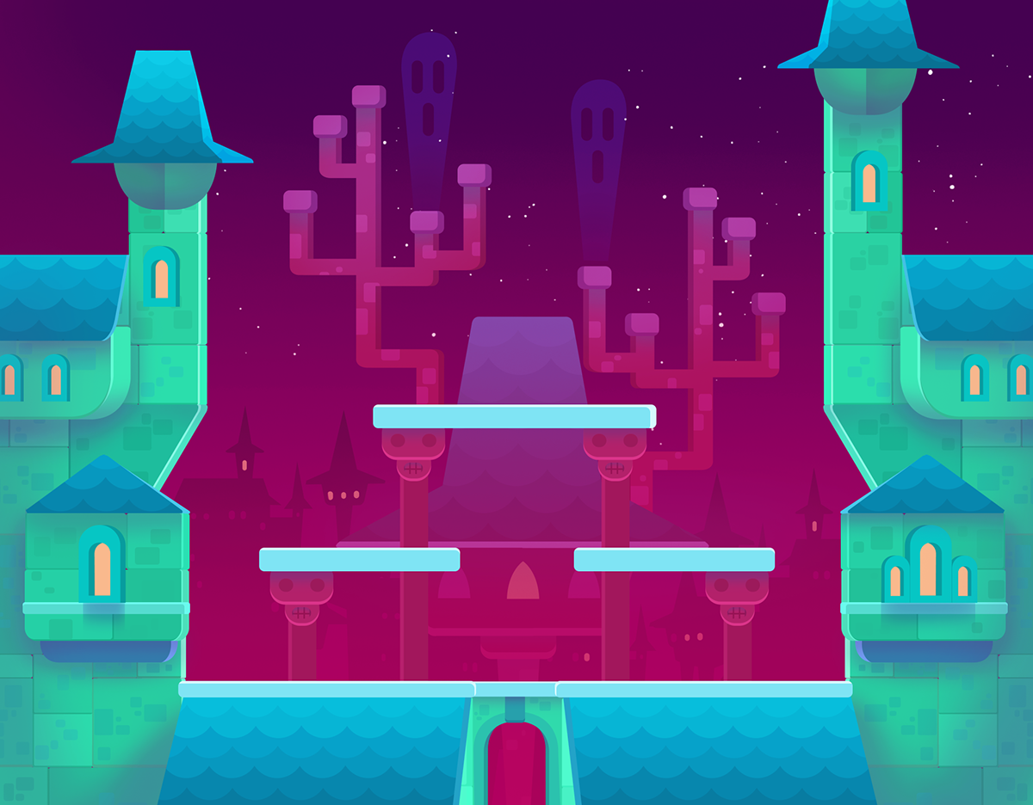

**Color**

* There is a gradient used in the background.



* Not monochromatic, not complementary.
* Could be **tetradic**? Mainly there are **4 colors being used**: Background(with a gradient), Roof of the castle (with different saturation and brightness), castle walls (with different saturation and brightness) and Windows. Besides, all the 4 colors are evenly spaced in the color wheel.
* I can see that the elements in the front (castle) are more brighter than the elements in the back. Maybe to represent the night in the background and the castle is iluminated. **Background** has **low value** (the sky) to represent the night, while the castle and **elements in the front have a high value**

**Lines**

* Some of the lines are used to represent textures, like for the roof of the castle



**Shapes**

* Shapes in general are very rectangular. Using a lot of rectangles and triangles, and they represent human constructions.



* There are some shapes that are rounded in the corners.



* Rectangular shapes are used to represent texture, like the castle brick for example.



**Texture**